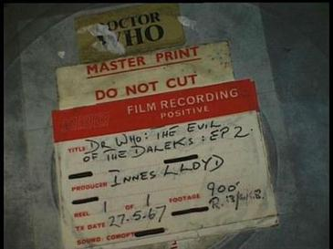

The BBC has just discovered a missing episode of Dr. Who on 16mm telerecording film, and has created a high quality preservation file in MXF format. Please create a record that encompasses these formats.

Extra credit challenge: if the BBC also creates a Blu-Ray for distribution, how would you add that to the record? What about an MP4 access copy?

